**Covariance**

**Introduction:**

Covariance is a measure of how changes in one variable are associated with changes in a second variable. Specifically, covariance measures the degree to which two variables are linearly associated. However, it is also often used informally as a general measure of how monotonically related two variables are.

In [probability theory](https://en.wikipedia.org/wiki/Probability_theory) and [statistics](https://en.wikipedia.org/wiki/Statistics), covariance is a measure of how much two [random variables](https://en.wikipedia.org/wiki/Random_variable) change together. If the greater values of one variable mainly correspond with the greater values of the other variable, and the same holds for the lesser values, i.e., the variables tend to show similar behavior, the covariance is positive. For example, as a balloon is blown up it gets larger in all dimensions. In the opposite case, when the greater values of one variable mainly correspond to the lesser values of the other, i.e., the variables tend to show opposite behavior, the covariance is negative. If a sealed balloon is squashed in one dimension then it will expand in the other two. The sign of the covariance therefore shows the tendency in the [linear relationship](https://en.wikipedia.org/wiki/Linear_relationship) between the variables.

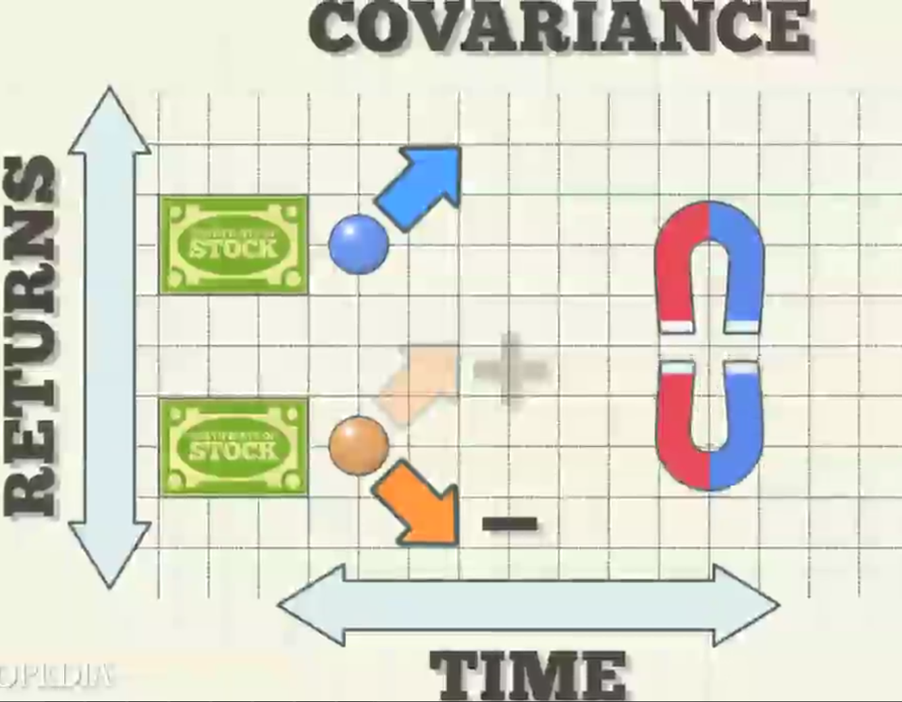

Variables whose covariance is zero are called [uncorrelated](https://en.wikipedia.org/wiki/Uncorrelated) variables.

Covariance can be calculated as



Where E(X) = mean of variable X

E(Y) = mean of variable Y

Various tools have function or functionality to identify covariance between variables. In Excel, function COVAR() is used to return the covariance between two variables and SAS uses procedure PROC COV to identify the covariance.

Applications:

1. By using covariance, a portfolio manager can identify if the portfolio is adequately diversified

Interview Questions:

1. Define Covariance and its formula?
2. What is the difference between covariance and correlation?
3. What are the units of covariance?